**Principles of Sociology – SOC1301**

**Spring 2020**

**Al Akhawayn University**

Professor: McDaniel, Steve

Office: Building 6, Room 105

Phone: 2146

Email: S.McDaniel@aui.ma

Office Hours: by appointment or MWF 8:30–9, 9:50–10. 10:50-11, 11:50-12,12:50 – 2

**Text**

Ferrante, J. 2008. **Sociology: A Global Perspective. 9th edition. International Student Edition**. Thompson-Wadsworth.

If the only tool you have is a hammer, you tend to see every problem as a nail.   
[**Abraham Maslow**](http://www.brainyquote.com/quotes/quotes/a/abrahammas107087.html)

**Introduction**

Society is perhaps the greatest human invention. It more or less meets the survival, emotional, intellectual and even the spiritual needs of most of its members. It has allowed people, as biological organisms, to adapt to and live in every environmental region on Earth and even in outer space. It provides the means for us individually and collectively to use our greatest asset - our ability to learn, to create. Yet society requires something in return. It requires some degree of subordination of the individual to the collective. We are not as free to behave as many people think we are. Society as we know it would not be possible without social control. And society enforces that subordination of the individual to the collective through sanctions ranging from disapproving looks, to the death penalty. Yet through all of the socially constructed and maintained constraints upon us we do have some degree of autonomy and some real freedom.

Unfortunately, a great many people never fully see or understand either the constraints they live under or the real freedom they have. They just keep swinging away at the problems of the world with their hammer. One of the great contributions of Sociology is that it can show us both the constraints and freedom and thereby enable us to lead more full and productive lives. The main objective of this course is to show each of you how to think sociologically - how to understand and use the sociological perspective. Or to put it another way: to teach you to see the social structures and forces that constrain us, and then to see the freedom you actually have.

In this course, we will sample a number of important ideas and sub-disciplines in sociology, but by no means all of them. This syllabus tells you what topics we will introduce and when in the semester we will explore them. Though it is an introductory course, our secondary goal is to generate interest in Sociology. I hope that in this course you pick up a few more tools to put in your belt and that through greater knowledge you will be more prepared to have a happier and more useful life.

**Other Quotes:**

The dead governs the living.   
 **-**[Auguste Comte](http://www.brainyquote.com/quotes/quotes/a/augustecom190405.html)

In the sky, there is no distinction of east and west; people create distinctions out of their own minds and then believe them to be true.   
 **-**[Buddha](http://www.brainyquote.com/quotes/quotes/b/buddha131975.html)

Few people are capable of expressing with equanimity opinions which differ from the prejudices of their social environment. Most people are even incapable of forming such opinions.   
 **-**[Albert Einstein](http://www.brainyquote.com/quotes/quotes/a/alberteins148811.html)

All, too, will bear in mind this sacred principle, that though the will of the majority is in all cases to prevail, that will to be rightful must be reasonable; that the minority possess their equal rights, which equal law must protect, and to violate would be oppression.   
 **-**[Thomas Jefferson](http://www.brainyquote.com/quotes/quotes/t/thomasjeff135371.html)

As I would not be a slave, so I would not be a master. This expresses my idea of democracy.   
 **-**[Abraham Lincoln](http://www.brainyquote.com/quotes/quotes/a/abrahamlin101394.html)

America and Islam are not exclusive and need not be in competition. Instead, they overlap, and share common principles of justice and progress, tolerance and the dignity of all human beings.

**-**[Barack Obama](http://www.brainyquote.com/quotes/quotes/b/barackobam410719.html)

**It is not righteousness that you turn your faces toward East or West, but it is righteousness to believe in God, the last day, the angels, the Book, the messengers and to give your wealth out of love for Him to your kin, to the orphans, to the poor who beg, and to the wayfarer, and to those who ask and to set slaves free;**

**-Koran 2;177**

**Course Objectives**

1. Student will learn a global perspective in the light of transnational relationships and local forces.
2. Student will learn to evaluate global events in the light of historical and cultural dynamics. Student will be responsible for explaining global events in terms of those dynamics.
3. Student will be able to evaluate and discuss his own personal development in the light of local and global forces. Student will be required to discuss personal and cultural dynamics in light of those forces and apply that discussion to assigned articles.
4. Teach you to think sociologically and critically.
5. Student will learn to think sociologically with an objective look at historical events, current global events, social inequality, gender ideas, race dynamics, family issues, religious perspectives, and general population factors such as education, health care and the environment… that have shaped and are shaping learned behaviors.
6. Student will be required to provide feedback from assigned articles and class discussions regarding the topics noted above. Student will be required to provide historical and personal examples that demonstrate critical thinking.
7. Student will be required to write a summary of peer-reviewed article while noting the importance of an academic literature review, the design of scientific research, how to analyze statistics, how to critically respond to research results, and how to use APA formatting.
8. Student will apply his sociological skills and critical thinking skills in writing a creative research paper that is foundationally supported with peer reviewed journal resources.
9. Student will be required to participate and report on 3 on-campus activities where he can note and define the social forces involved in those activities.
10. Introduce you to some of the foundational ideas of sociology.
11. Student will learn the historical and academic features that shaped modern sociological studies.
12. Student will be able to discuss the significance of Comte, Marx, Durkheim, Weber, and DuBois.
13. Student will develop a social imagination and be able to apply sociological theories to current events to explain the dynamics of those events.
14. Student will learn about the biological and psychological side of sociology.

**Grades**

Quizzes ( 3) 45%

FINAL Exam(Comprehensive) 20%

Participation 12%

Research Papers 15%

Chapter Outlines 6% Online Racism test 2%

Exam and Quizzes: Keeping up with the reading is very important. There will be two quizzes; one before and after the midterm, as well as a MIDTERM and FINAL Exam. While the quizzes are not cumulative the final exam will be. You may see quiz questions on the final. The exam and quizzes use multiple choice, true/false and discussion type questions. – usually divided into thirds. The midterm and final will be all discussion.

**Participation** and assignments: Trying to answer questions that I ask, and asking questions and speaking up when you see connections between course material and your own experience are important in this class. Although we have a lot of material to cover, I will do my best to give you opportunities to individualize your learning. To that end, I will also be incorporating occasional, graded or un-graded individual or group exercises into our class time. Every absence, excused or not will lower your participation grade by 3%. Three late-to-class marks will equal one absence.

You will have at least two (2) **papers** to write, and to turn in through Turn-It-In.Com. 1)Your first paper will be a **summary paper** (5%) that requires no research, but is simply to familiarize you with a peer-reviewed paper – the kind you will be using for your research. This will be a 1200-1300 word summary to be turned in on turnitin.com

2)*Your second paper is **an actual research paper (10%)**. No opinions and no quotes. This paper should be at least 2000 - 2300 words and be based on your research that uses at least 5 scientific, peer-reviewed sources. Use APA formatting for citations and references.(See our text as the example). You will need to select your research topic by 2/24 and provide the list of the 5 research Journals that you will be basing your research on.

**Chapter Reviews (3)** – You will need to write **three** of these during the semester. We are going to study roughly 14 chapters, But I want you to apply 3 chapters to your life. Chapters 3, 6, and 9. Check the calendar for due dates. It is best to read a chapter while thinking – “How does this apply to me?” “How does this affect my ability to think or learn?” “How will this concept or idea impact my performance?” etc. You then need to write 10 questions that apply to you and then fully answer your own question. Questions and answers should be insightful and thorough. **To be submitted through turnitin.com.**

**Online Racism Test**: 2% of your overall grade. Go to Harvard Implicit Association test and take their black-white racism test. Report your findings in a couple of sentences on Turnitin.com.

**Policies**

Late Work: Late work will NOT be accepted – no excuses. Any assignment turned in after the due date will not receive any credits. Where there are specific due dates for assignments, I expect you to submit your work at the beginning of class or when I collect the assignments. The only exceptions to this would be if you have a university-approved absence that prevents you from submitting your work on time, or if you are participating in athletic events or other group activities sponsored by the university.

Incomplete Grades: Incompletes will be given in extreme circumstances and only with university approval. You must talk to me before the final exam to arrange an incomplete.

Attendance: The university’s attendance policy is clearly stated in the student handbook (please refer to <http://www.aui.ma/DSA/dsa-studenthandbook.pdf> pp35-37). You are expected to follow this policy in this class and will receive a “WF” after five unapproved absences as per the policy.

While attending class is not the same as participating in class, you cannot participate if you are not there. Consequently and in conjunction with the university’s attendance policy (see below) I will deduct one participation point for every class that you miss.

If you are late to class – if you arrive before I take attendance and call your name, that is ok. But when I call your name or look to see if you are there yet and you don’t answer or aren’t there, then I will consider you late; 3 lates = one unexcused absence.

Grading: This course will use the usual grade scale: 90-100% = A, 80-89.9% = B, 70-79.9% = C, 60-69.9% = D, >60% = F. Course grades may be curved at the teacher’s discretion.

On papers, I grade on how well the student met the requirements of the assignment. Please talk to me if you feel that your work did not receive the full credit it was due. If you want I will re-grade your paper and the new grade will replace the old one in my records. To be clear, the new grade can be lower than the old one.

Academic Integrity: Be forewarned, I hate cheating. So that you are clear on the university’s policy, I have pasted it here for you (downloaded from <http://www.aui.ma/DSA/dsa-studenthandbook.pdf> August 18, 2007).

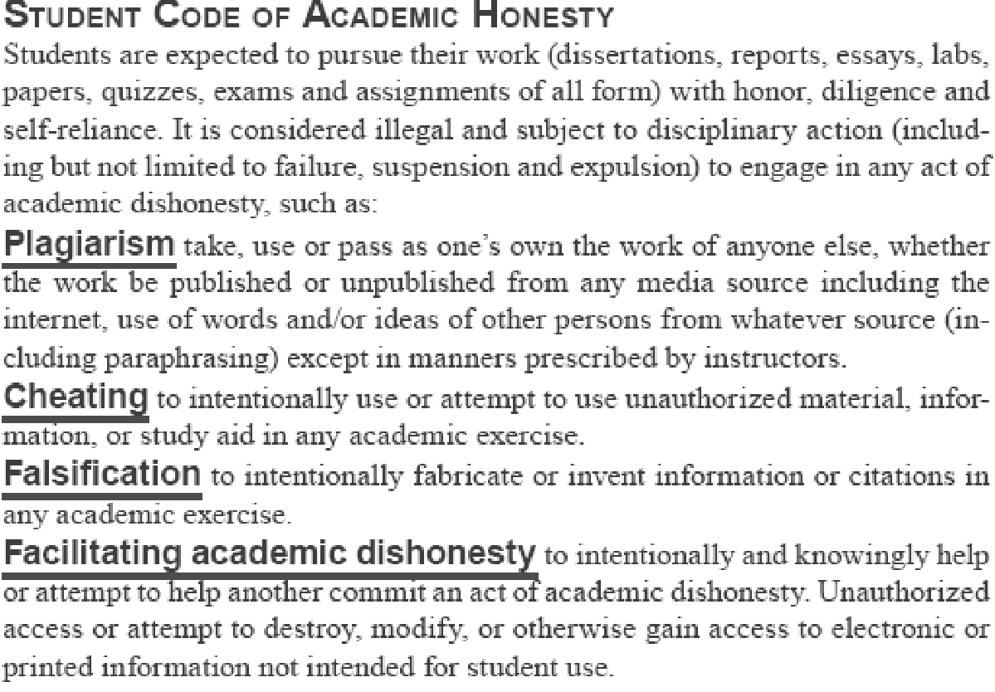

You will be required to submit any papers for this class through turnitin.com.

During exams or quizzes, talking to any other student or looking at their paper for any reason is grounds for receiving a “0” on the test or quiz.

Cell phones: Cell phones are strictly prohibited during tests and quizzes.

Disabilities: Any student with a documented disability (e.g., physical, learning, psychiatric, vision, hearing, etc.) who needs to arrange reasonable accommodations should contact me. I will do my best to provide such accommodations.

Sexual Harassment: University policy prohibits sexual harassment of all kinds. Complaints about sexual harassment should be reported to AUI student counseling services. (See the Al Akhawayn University Student Handbook, p 38 for more information <http://www.aui.ma/DSA/dsa-studenthandbook.pdf>)

Inclusive Language: It is imperative in this class, as well as important in an education/work setting, that inclusive language be used in both oral and written communication. Inclusiveness refers to the use of language that assumes equality of the sexes and the equal importance of members of all cultural groups.

Gender inclusiveness means that usage such as "he" and "man" as generic references to humanity or people in general are not appropriate. While avoiding such use is sometimes awkward if one's habits to the contrary are deeply ingrained, it is essential and possible to do so. Therefore, I suggest that you use plurals (e.g. "workers…they," rather than "worker…he"), some combination of pronouns (e.g., (s)he, s/he, he/she or alternative words (e.g., "people" rather than "mankind").

Cultural inclusiveness means that classroom discussion (and written materials) will not assume that class members or all members of organizations are from Moroccan culture. Respect for the diversity of the class and the multicultural world in which organizations operate will be expected.

Make-up Exams and Quizzes: There are no makeup exams. I will allow you to drop one quiz for a university approved absence (see Attendance Policy in http://www.aui.ma/DSA/dsa-studenthandbook.pdf ).Midterm and Final Exams cannot be missed – doing so will result in a zero for that exam. See the calendar for dates.

APA style: To avoid plagiarism and adjust to how professionals share and verify each other’s work, you must use APA (American Psychological Association) style for all citations. (Please see the Center for Academic Development – Writing Program <http://www.aui.ma/VPAA/cads/writingcentre/apastyle/cad-wc-apa-styleguidelines.htm> for more information.)

**Advice**

If you have any difficulty at all that affects your learning in this class, please see me immediately. I am here to help you maximize your learning. Anything that limits this is something that I will help you with.

If you are new to college you may find that your study skills (e.g. text reading, note-taking, listening, writing papers, taking tests, managing time) need improvement for you to succeed. I can help you with this. Also the university’s counseling center has many resources available to help you succeed as a student. Please see their website for more information ( <http://www.aui.ma/DSA/counseling/counseling-index.htm> and http://www.dr-bob.org/vpc/virtulets.html#Study-Skills ).

Keep all graded papers and email correspondence from me until after you receive your course grade. Should any questions arise about your grade, these records may be your only support.

**Schedule of Events**

|  |  |  |  |
| --- | --- | --- | --- |
| Week - dates | Topic | Reading | Assignments & Tests |
| **1** – 1/20,22,24 | Intro to course  Social Imagination | Ch.1  Sugar  Action Games | Action Game summary due 3/1 |
| **2** – 1/27,29,31 | Social research | Ch 2  Brazil and TV |  |
| **3** 2 /3,5,7 | Culture | Ch 3  Pinker  HowCulture... | First chapter outline of chapter 3 with 10 Q&A due….2/ 1 |
| **4** – 2/10,12,14 | **Socialization** | Ch 4  Waxman | **Quiz 1 – 2/ 7** |
| **5** – 2/17,19,21 | Social Interaction | Ch 5  Teen Brain  JohnDean | **2nd chap 6 Q&A due 2/23** |
| **6** – 2/24,26,28 | Formal Organizations | Ch 6  TV Zombies | **1st Summary due 3/1**  Research Articles due 3/22 |
| **7 –** 3/ 2,4,6 | Deviance | Ch 7  KoreanCrash | Quiz 2 - 3/ 4 |
| 3/ 9 -13 | **SPRING BREAK** |  |  |
| 8 - 3/ 16,18,20 | **Social Inequality** | Ch 8  Caging of US | Ch 9 Q&A due 3/22  ONLINE racism due 3/29 |
| **9** –3/23,25,27 | Race and Ethnicity | Ch 9  InterracialMar |  |
| **10** – 3/ 30 - 4/ 1,3 | Gender | Ch 10  Sexual Orient |  |
| **12** –– 4/6,8,10 | Economics/ Politics | Ch 11 | **Quiz 3 - 4/10** |
| 13 – 4/13,15,17 | Family | Ch 12 | **Research Paper**  due 4/12 |
| 14 – 4/20,22,24 | Education | Ch 13 |  |
| 15 – 4/ 27,29 - 5/ 1 | Religion | Ch 14  BuddhaRising |  |
| 16 – 5/ 4,6 | Health Care | Ch 15 |  |
| TBA |  | | **FINAL EXAM**  **Chap 1 - 15** |

*Note: this schedule is subject to change and changes will be announced in class. All students are responsible for following announced changes.