LECTURE TITLE LIST FOR
PS427 / PS407 Academic Year 2022/23

PS427: Forensic, Abnormal and Clinical Psychology
All Psychology Students

PS407: Forensic, Abnormal and Clinical Psychology
1st Year Occupational Therapy
2nd year Law (Criminology and Criminal Justice)

Coordinators: Dr John Bogue & Dr Jonathan Egan
Date | Lecture# | Lecture Title | Section |  | Chap
09.01.23 | L1 | Introduction to Module and Introduction to Forensic Psychology | A
16.01.23 | L2 | Eyewitness Evidence | A |  | 7 & 11
24.01.22 | L3 | Interviewing Suspects | A |  | 9
30.01.23 | L4 | Supporting Vulnerable Witnesses | A |  | 8
06.02.23 |  | Bank Holiday
13.02.23 | L5 | Detecting Deception | A |  | 10
20.02.23 | L6 | Anxiety Disorders | B |  | 1
27.02.23 | L7 | Mood Disorders | B |  | 2
06.03.23 | L8 | Personality Disorders | B |  | 5
13.03.23 | L9 | Psychotic Disorders | B |  | 3
20.03.23 | L10 | Eating Disorders | B |  | 4
27.03.23 | L11 | Module Review/ Overview/ | A & B

Lectures will run from 5pm to 7pm in Kirwan Theatre

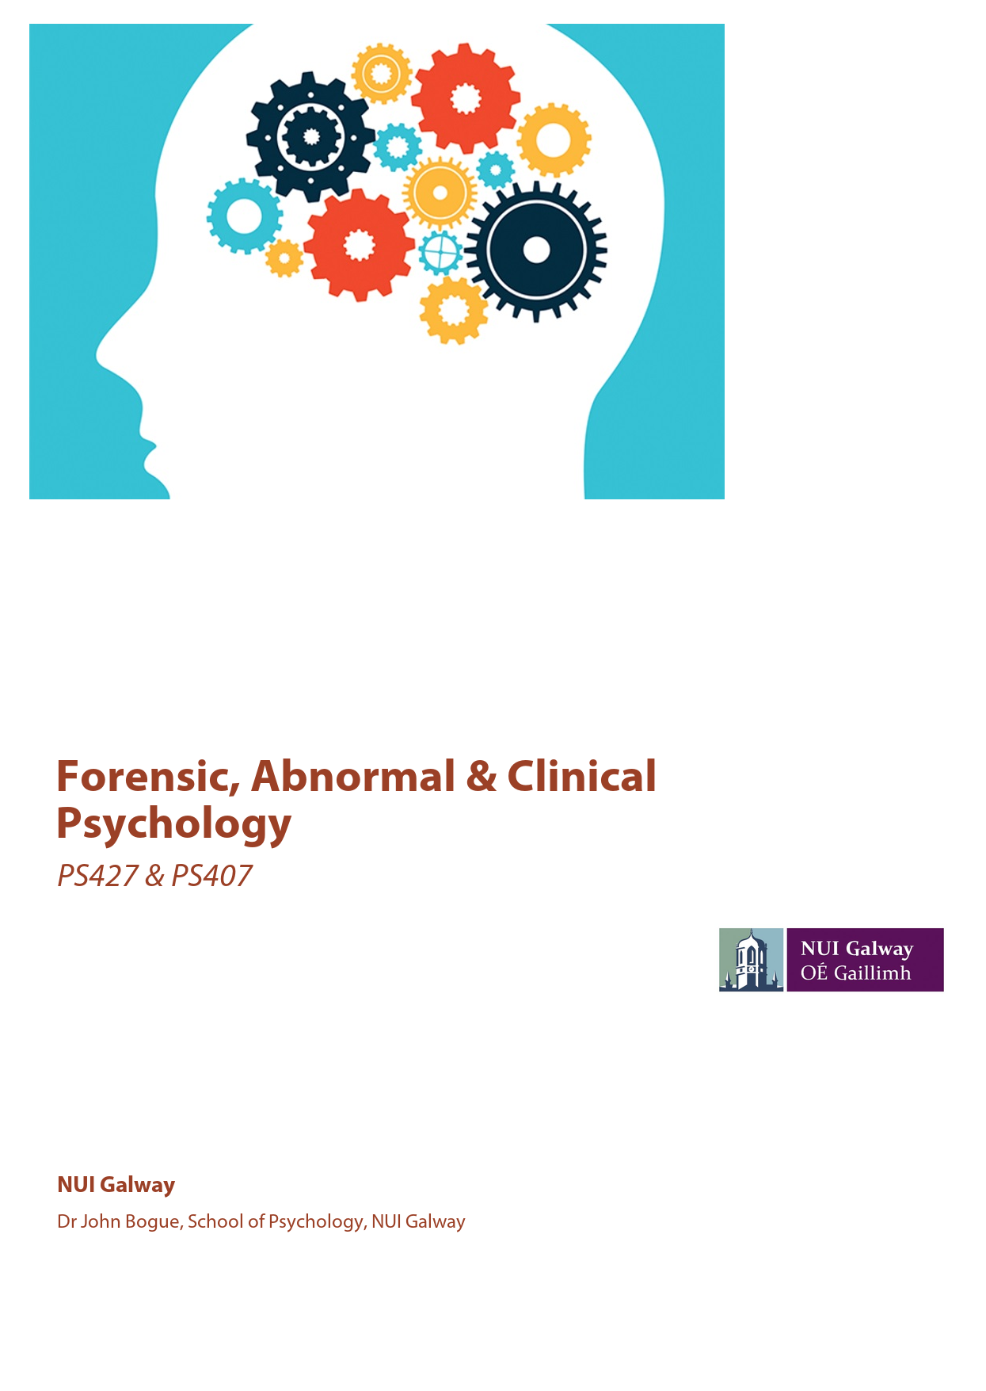
Please consult Blackboard frequently for updates.
Exam format: essays will replace exams.
Two Essay Questions (1,500 words max each)
Due dates: Essay A 17/03/23 and Essay B 28/04/23
One essay will be from Section A and One essay will be from Section B
The Required Textbook is:
Forensic, Abnormal and Clinical Psychology (2021)
Author: Graham Davey Compiled by: John Bogue, Wiley Custom
ISBN : 9781119924883
MMS ID : 991000421187603626
Students will need to select the Ireland store by clicking on the flag in the top corner and the pricing will change to Euro.
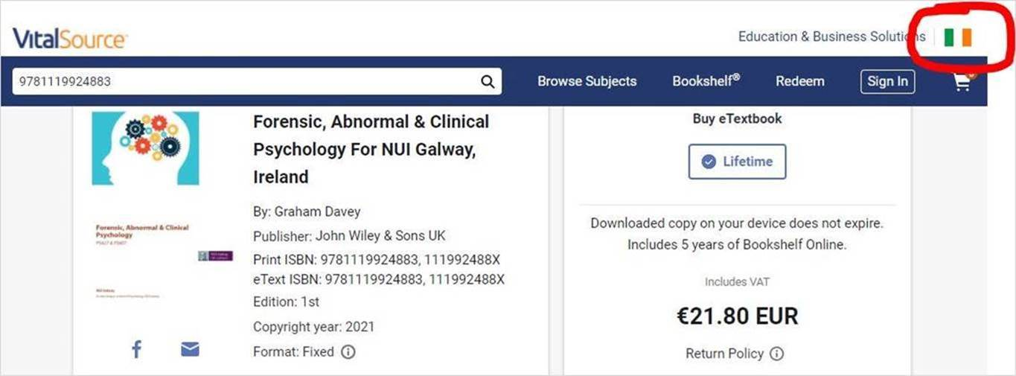
https://www.vitalsource.com/ie/products/forensic-abnormal-amp-clinical-psychology-for-nui-graham-davey-v9781119924883?term=9781119924883
The above textbook has been specially compiled for this module. Significant resource material for individual lectures will also be available on Blackboard and as advised by lecturer.
Other reading available in the James Hardiman Library:
Davey, G. (2021). Psychopathology: Research, Assessment and Treatment in Clinical Psychology. London: British Psychological Society
Davey, G. (2014). Psychopathology: Research, Assessment and Treatment in Clinical Psychology. Chichester: Wiley
Davey, G. (2008). Psychopathology: Research, Assessment and Treatment in Clinical Psychology. Oxford: BPS Blackwell
Davies, G. and Beech, A. (2017). Forensic Psychology: Crime, Justice. Chichester: Wiley [also available as an E-Text in library]
Holmes, D. A. (2010). Abnormal, Clinical and Forensic Psychology. Harlow: Pearson. [also available as an E-Text in library]

